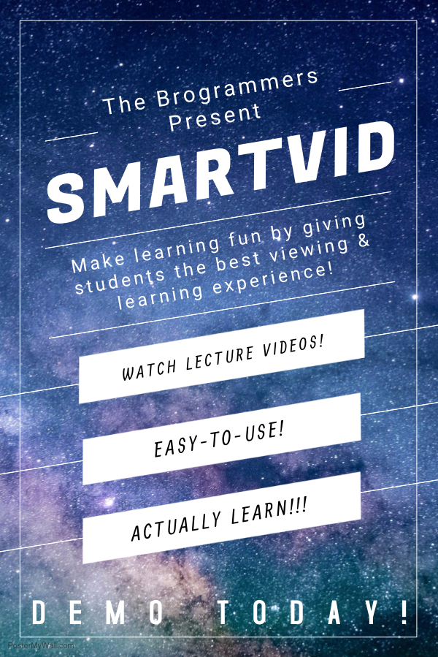

SmartVid Final Report

Alex McWhorter, Cal Gordon, Steven Biedenbach, & Sagar Hansalia

**Overview**

SmartVid is an educational platform designed to enable professors to create a more interactive learning experience by uploading videos to be viewed by their active classes. The benefit of SmartVid is that the videos created by the professors will be tailored toward the classes they teach, providing a personalized resource where students can access the material their professors are teaching. Additionally, professors will be able to monitor the activity of their students via progress bars showing how much of the video (and which part) the students have viewed. This will be coupled with periodically introduced quizzes as the video is viewed, designed by the professor(s). A professor would then be able to decide what action would be taken if the student fails the quiz (IE: the student must re-watch the video, the quiz must be immediately retaken, etc.).

**Features Implemented**

At present, students and professors are able to register and sign-in to their accounts, view information about SmartVid and its creators, and visit the primary professor dashboard.

**Remaining Work**

**Upload Videos**: The main issue with the implementation of an uploading process is having a designated system to store the files associated with SmartVid. Our plan was to utilize YouTube’s abundantly available storage alongside the integration of the YouTube Data API. The plan is to host the videos on YouTube and use the API to pull vital information from the uploaded videos on demand, for example:

A video titled “Introduction to Titration” may have a length of 5 minutes 30 seconds, a brief summary, related tags, and similar videos. By using the YouTube API, we would be able to make calls outputting the aforementioned information in the console, which we could then interact with further. (Continued below under **View Progress Bars** and **Create and Review Quizzes**).

**Create Classes**: We at SmartVid sought a method for professors to tailor fit their applied teaching techniques to a particular class, regardless of other classes they are teaching. What this means is that, for example, a Chemistry professor may teach an introductory course during the same semester as an advanced course, and we wanted to create a separation between the content of these courses. When complete, SmartVid will enable professors to designate content to specific class sections, organizing content in such a way that will not expose students to more advanced content prematurely, which we believe would only cause confusion.

**View Progress Bars**: Our completed project will have progress bars implemented, but was unfortunately hindered by our struggles with the YouTube Data API. As previously mentioned, the API enables us to pull data about a video and use it in other forms. Continuing from the previous example of a Chemistry video that is 5 minutes and 30 seconds long, we hoped to be able to create a progress bar using the following formula:

(**Current time on video** / **Total time on video**) * 100 = **Percentage Watched**

Additionally, we would disable the user’s ability to fast-forward through videos and also create “check-ins” to ensure the user is still watching the videos.

**Create and Review Quizzes**: Using the same tactic as the formula in the **View Progress Bars** section, we would permit professors to create pop-up quizzes at certain time frames (IE: following the end of a topic’s lesson). Based on the result of the quiz, the student would either be permitted to continue in the lesson or forced to rewatch and review the section of the video pertaining to the failed quiz topic.

**Functionality**

**Home Page**

This page is fully functional:

* **SmartVid** logo in top corner and **Home** link in the footer links back to home page at any time.
* **About** in header and footer links to a descriptive page about SmartVid and the Brogrammers.
* **Log In** links to the sign in page, listed below.
* **Sign Up** and **Sign Up Now!** buttonsLink to the registration page.

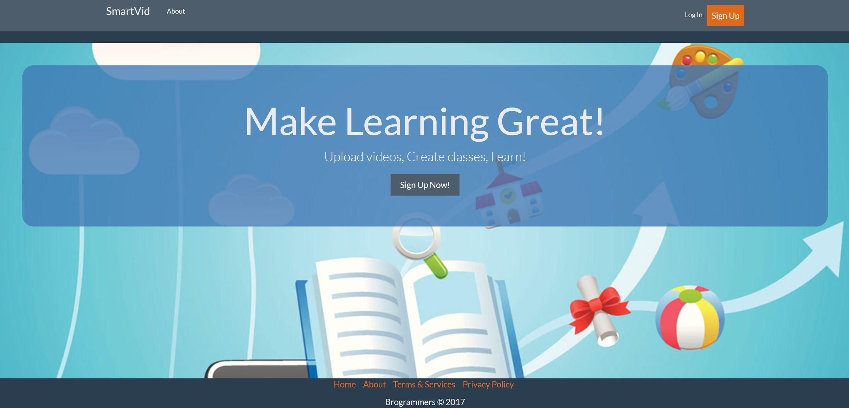

**Register**

This page is fully functional:

* (Header and footer same as home page)
* **Register Form** includes all fields required to register for SmartVid.
* **Email** must include the ‘@’ and ‘.’ symbols.
* **Account Type** is currently not working.
* **Terms and Conditions** must be accepted.
* **Submit** either sends information to database creating a user account, or fails the registration due to an input error.

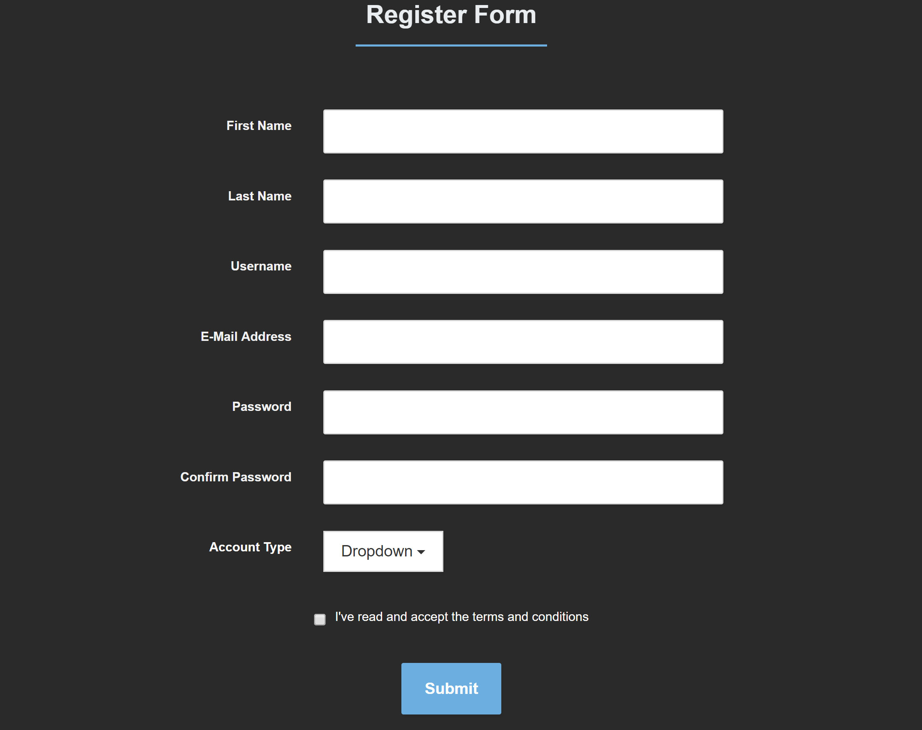

**Log-In**

This page is fully functional:

* (Header and footer same as home page)
* **Login Form** accepts username and password
* 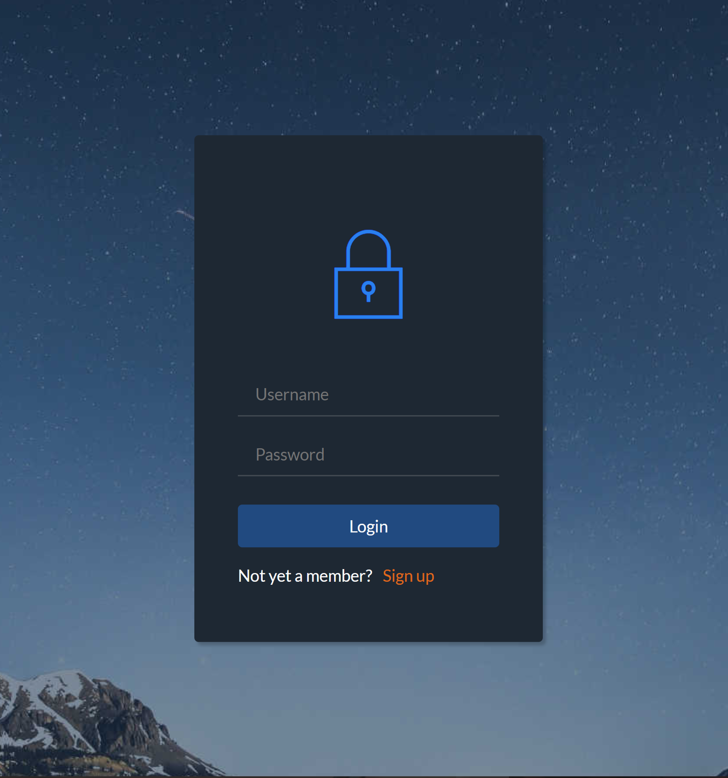Login button submits form and either kicks back an error for incorrect information or sends the user to the **Dashboard** if information matches.

**Dashboard**

This page is semi-functional:

* This page is part of index.php (logged in master page).
* A **welcome message** is added to the navbar.
* **Logout** link in navbar logs the user off and returns user to home page and main.php (logged out master page).
* **Home** button in navbar links user back to the dashboard with classes listed.
* The **Options** pane buttons dynamically change the main body panel to the desired panel.
* The **Classes** icons link to more information about the class and list of videos available from professor uploads.
* The **Footer** is the same as main.php.

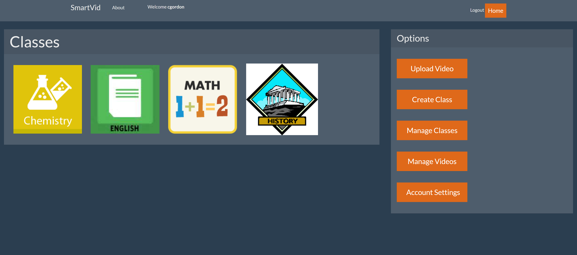

**View Videos**

This page is semi-functional:

* This page is part of index.php (logged in master page).
* The **Header** and **Footer** are the same as the **Dashboard**.
* The **Video** chosen from the dashboard is shown as the main video.
* A list of videos are dynamically queued on the right consisting of all the videos in a particular playlist or class.
* Below the main video is the title and description of the video.

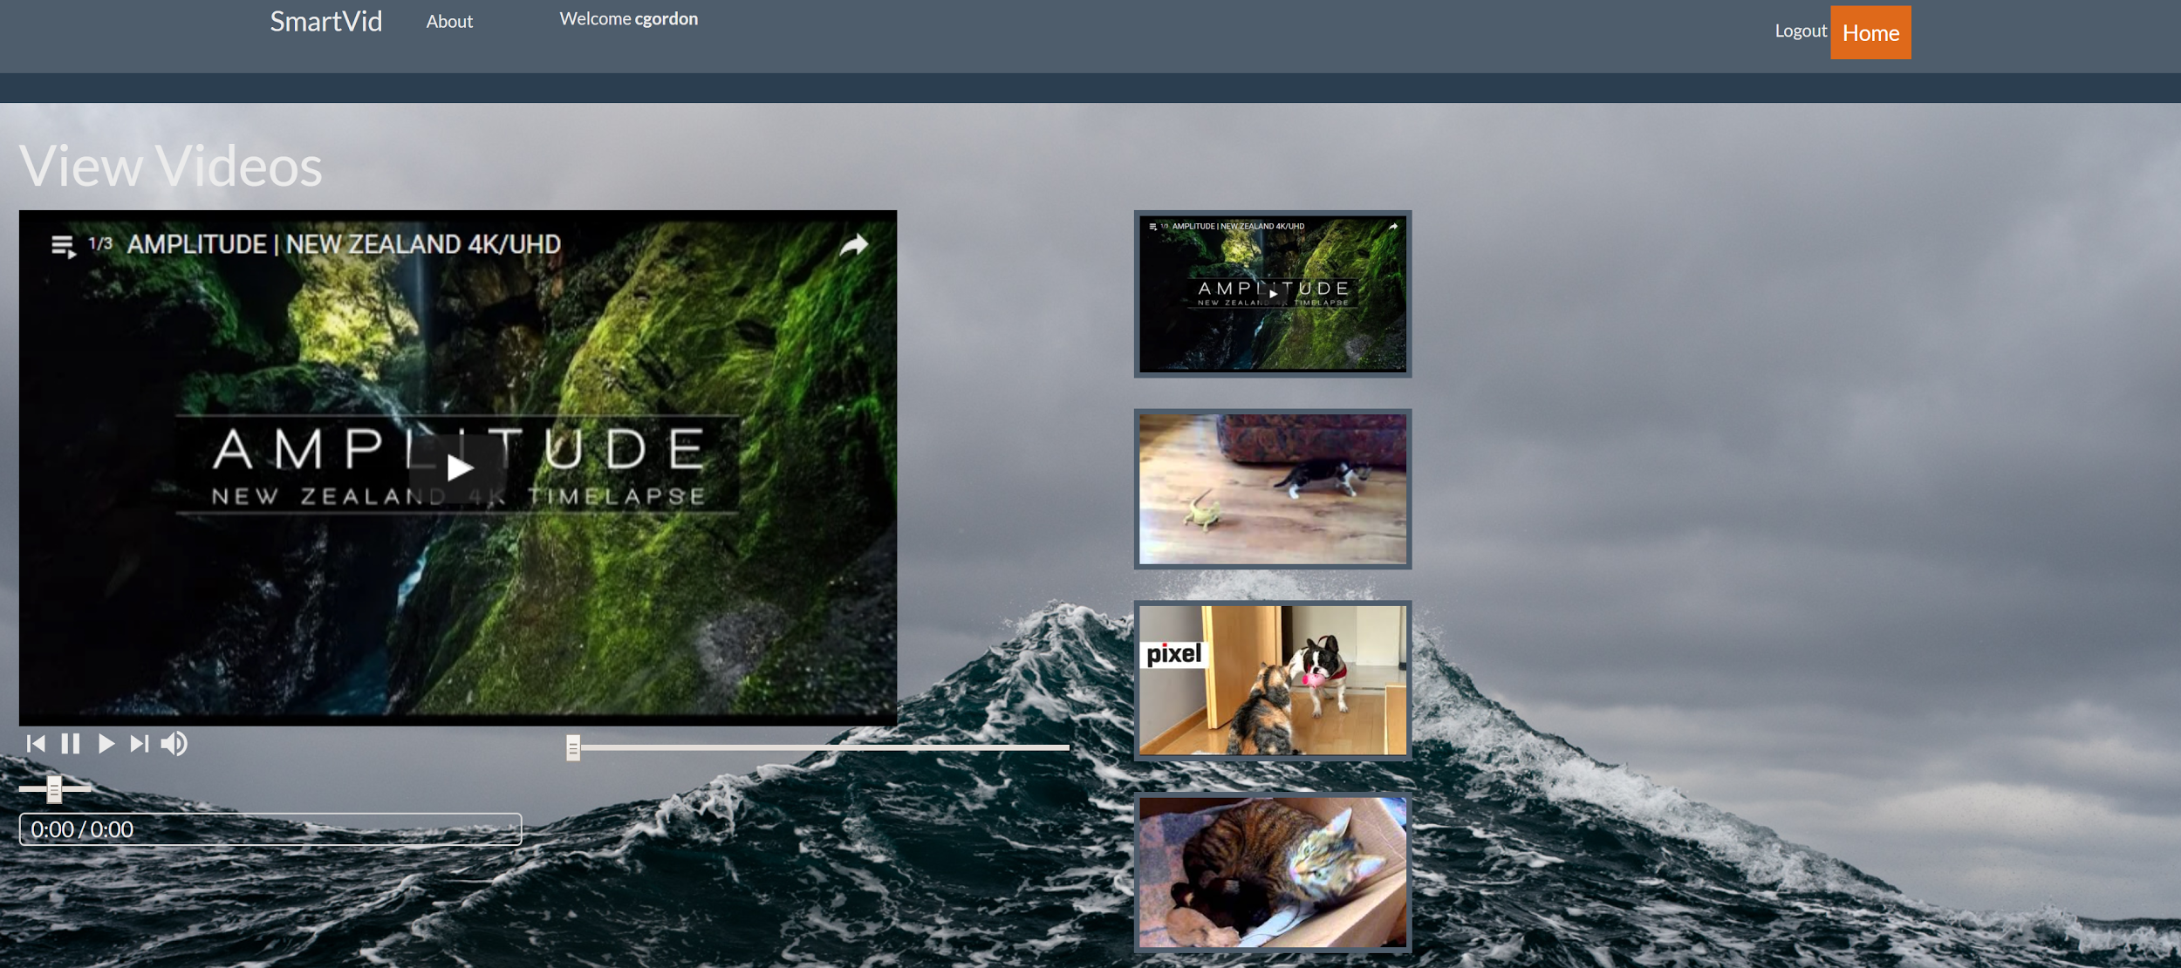

**\*\*\*Upload Videos, Progress Bars, and Quizzes are still in development.\*\*\***

[**Screencast**](https://www.youtube.com/watch?v=l2tCRhr-2lY&feature=youtu.be&hd=1)

Please click the link above to go to the YouTube video that shows Cal navigating and using SmartVid!

**Team Members**

Go to <http://www.calgordon.com/smartvid/model/main.php>, then click the “About” link at the top left corner. Then click the “Meet the Team” button in center of the page to view information on all SmartVid team members and our client.

**Testing Coverage**

The current version of SmartVid consists of two pages, main.php and index.php, which is where all testing took place. In our repository, test cases are organized into two folders based upon which page they occurred. All test case files for the two SmartVid pages are listed below:

* Main.php (logged **off** page)
  + aboutFunctions
  + incorrectPasswordRegistration
  + invalidEmailRegistration
  + loggingIn
  + missingInputFailedRegistration
  + registerUser
* Index.php (logged **on** page)
  + aboutFunctions
  + allProfOptionBtns
  + homeButton
  + logoutButton
  + viewVideo

**Testing Methods**

The automated testing process for our web application was done through the testing framework Selenium IDE. Selenium automated all test cases and allowed us to export them to PHP code via the extension PHPUnit, one of the most widely used testing frameworks for PHP. Automated/Unit testing was exclusively done through the Selenium IDE and PHP test functions can be viewed in our repository under /smartvid/testing.

**Testing Results**

The results for the automated testing are listed below in the order that was structured in the “Testing Coverage” section above. All results of the test cases passed, except one, “logoutButton” test case in index.php.

**ALL main.php test cases**

* 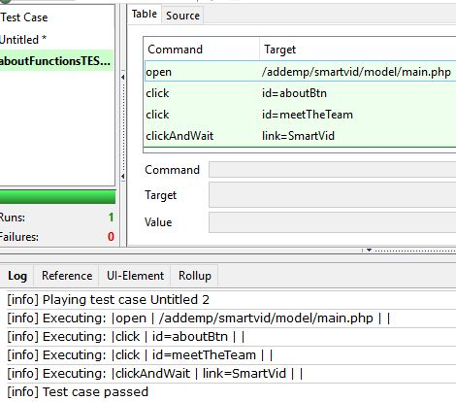

aboutFunctions

* 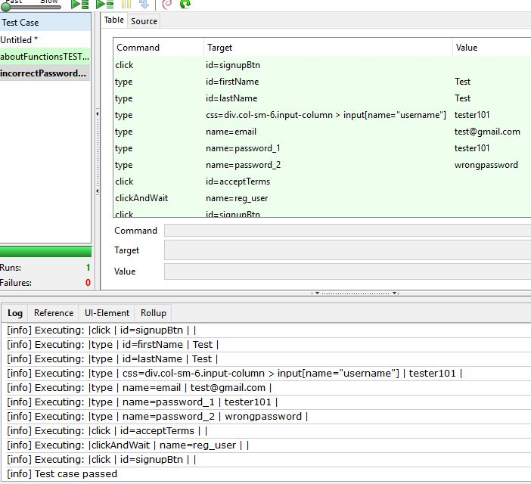

incorrectPassword

* 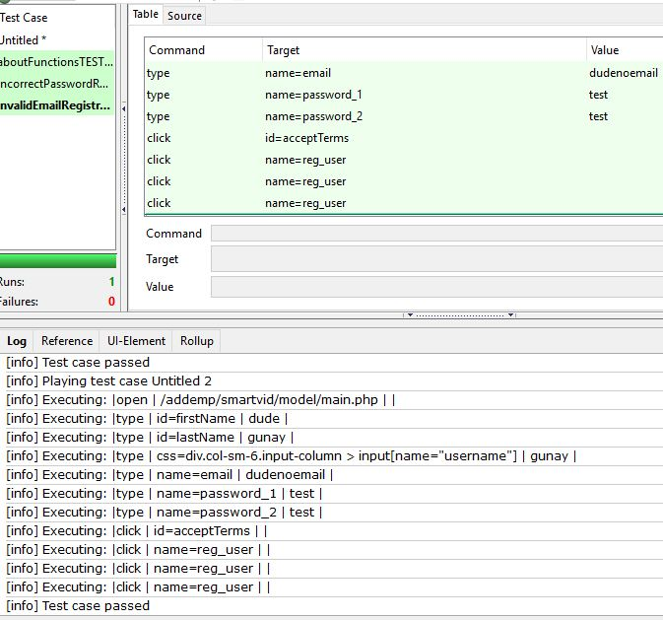

invalidEmailRegister

* 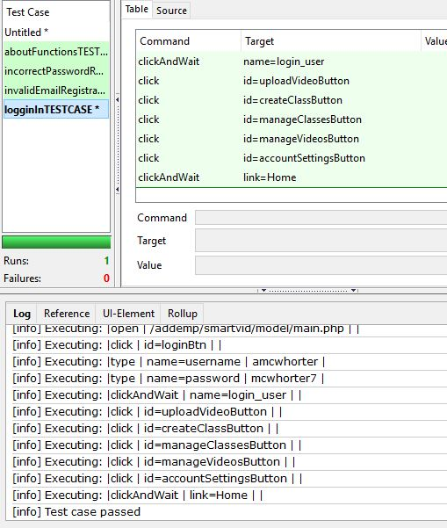

loginIn

* 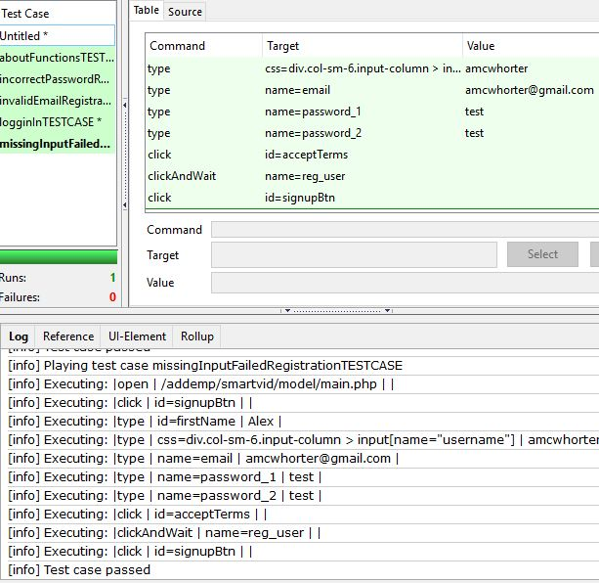

missingInputRegistration

* 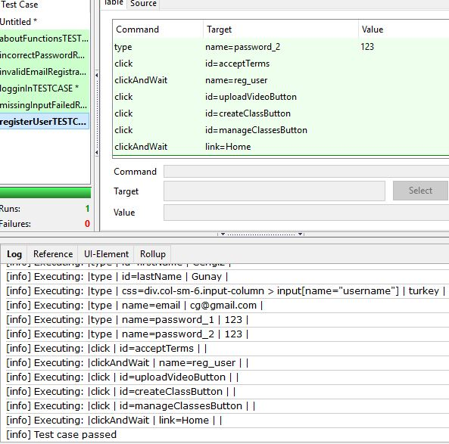

registerUser

**ALL test cases for index.php**

* 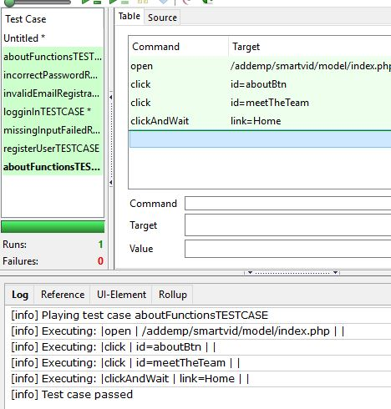

aboutFunctions

* 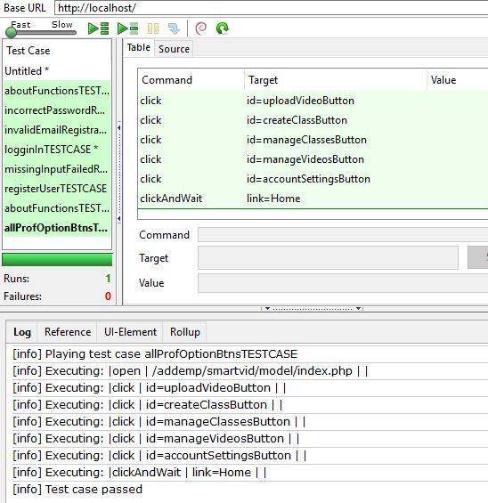

allProfOptions

* 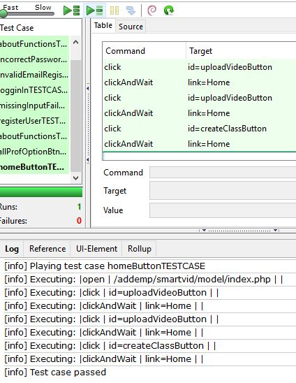

homeButton

* 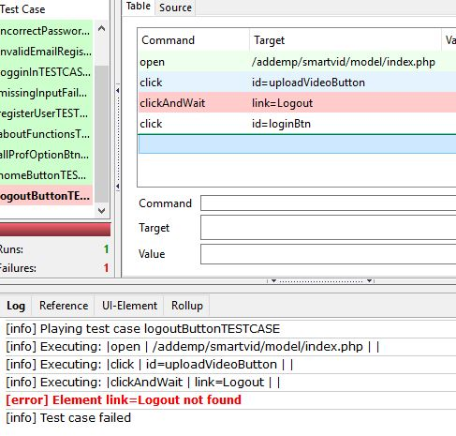

logoutButton

* 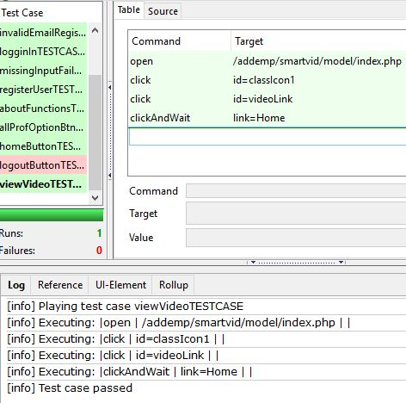

viewVideos

**Focus Group Survey Results**

What we were aiming for with the survey was to gather feedback about how SmartVid worked and what we could do to improve an already existing product. Because of this, we created a 8-question survey that users could take at the CREATE symposium after testing out SmartVid. This survey gathered information along the lines of if users would recommend it to others and if they would use this themselves. Also, it allowed users to input any additional comments or suggestions they had for SmartVid. The results of this survey can be seen in the next section.

**Usability Testing**

We asked users who used SmartVid to take a short, 8-question survey and here were the results:

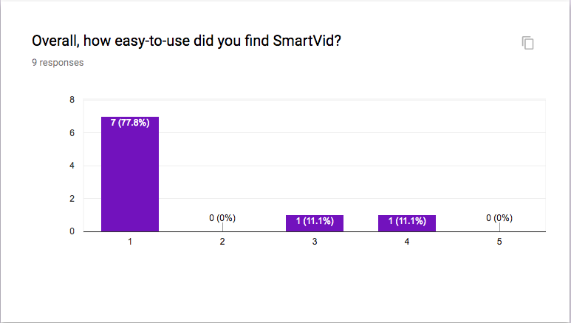* In this case, 1 was “Very easy to use” and 5 was “Very difficult to use”.

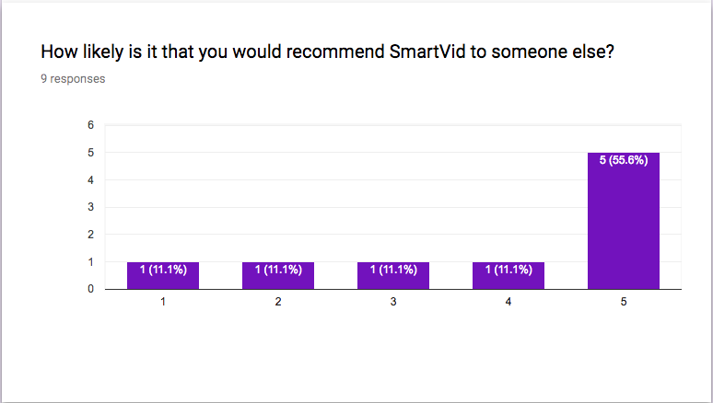* 5 was “Very likely to recommend to others”.

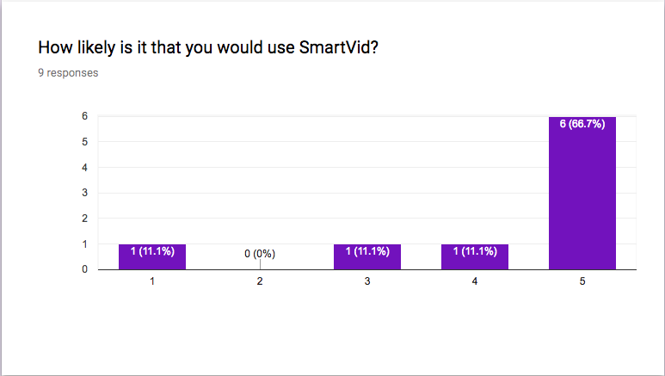

* 5 was “Very likely to use Smartvid”

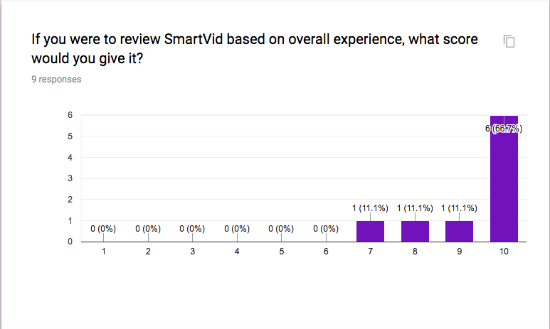

* These are standard ratings based on the 1 - 10 scale, 1 being a very low score and 10 being the highest.

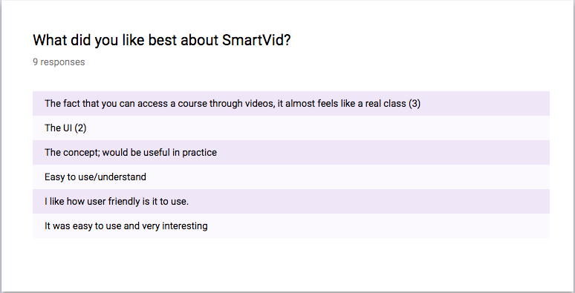

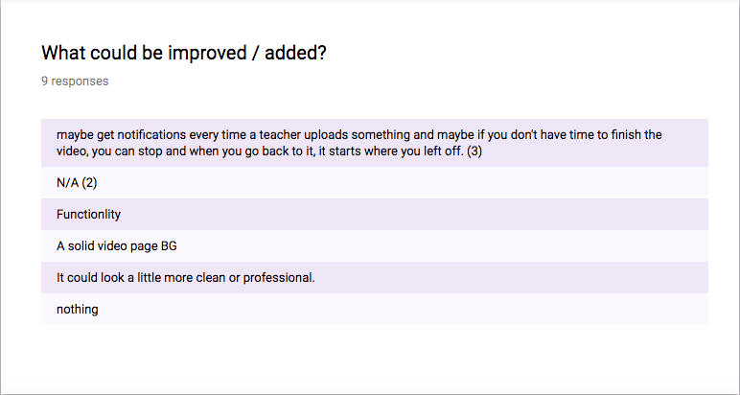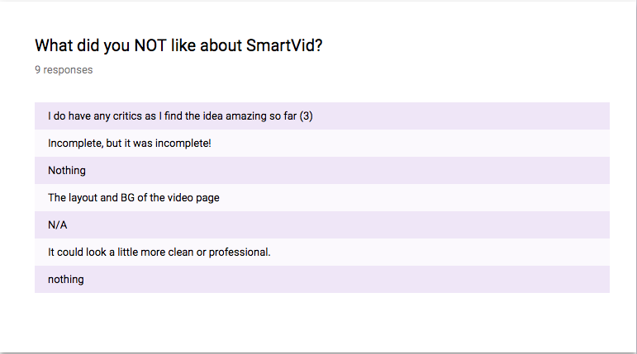

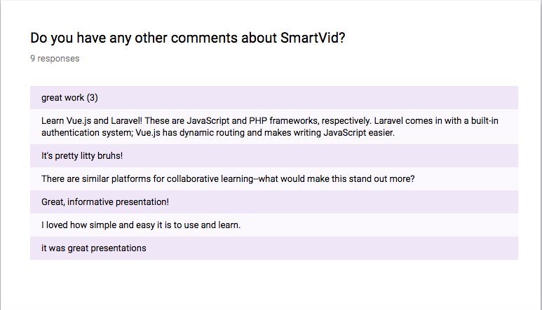When it came to the user survey and its results it became clear that the site was definitely user friendly, however, most people had rightfully said that they would now focus more on functionality. This was part of our plan but because of time constraints and a few other roadblocks, we weren’t able to complete them in time. These results are really helpful in that they guide us and tell us what the public wants. They tell us what we should focus on in the future.

**Installation**

Because SmartVid is a website, there is no installation necessary to use the service. Simply access the website, sign-up, and begin!

**Developer Installation**

For developers seeking to build upon SmartVid’s foundations, the installation instructions can all be found in SmartVid’s README document. An excerpt from that can be found below:

1. Download and install XAMPP: <https://www.apachefriends.org/index.html>

2. Navigate to */xampp/htdocs/addemp* folder

3. Download SmartVid repository: <https://bitbucket.org/cgunay-ggc/smartvid/overview>

4. Place **smartvid** folder from the repository inside the **addemp** folder

5. Start up XAMPP Control Panel

6. select the **start** action for the Apache and MySQL modules

7. Wait for the modules to be assigned port ID's and ports

8. The module names will be highlighted in **green** once the modules are ready

9. Open any web browser

10. In the URL box type: *localhost/addemp/smartvid/model/main.php*

11. The home page for the website will now be shown

12. To go directly to the **index** page (logged in view) type: *localhost/addemp/smartvid/model/index.php* in the URL window

**User Documentation**

If you need help using SmartVid, or are unsure how to register / login, please visit <http://www.calgordon.com/smartvid/model/main.php>. Then scroll or look to the bottom until you can see “Home”, “About”, “Help” and “Privacy Policy”. Click “Help” and there will be instructions on how to sign up, login and navigate our website.

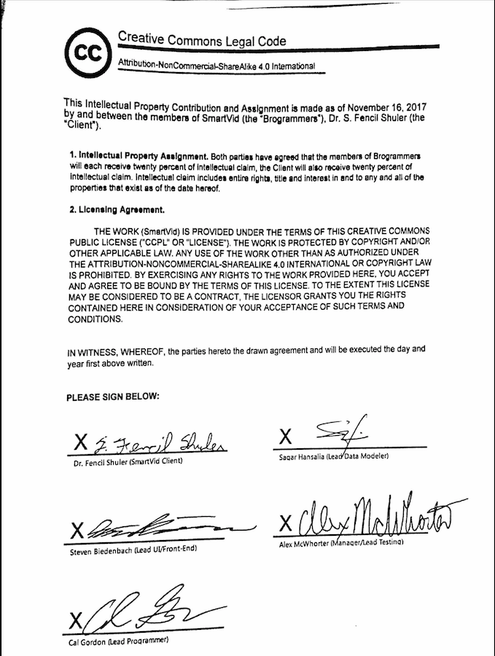**Software License**